**Mapping Real Estate Visuals Across America**

**🔍 Goal:**

Collect accurate pricing data for **real estate photography and videography services** for **all 35,705+ municipalities across the United States**, from **credible and market-specific sources**, to power a national pricing database.

**🧩 What Exactly Needs to Be Scraped**

We are targeting **business listings and websites** of service providers who **specialize in real estate media**, including the following services:

**🎯 Mandatory Services to Extract Pricing For:**

1. Photography
2. Videography
3. Drone Photography
4. Drone Video
5. 3D Virtual Tour
6. Floor Plans
7. Virtual Staging
8. Twilight Photography
9. Agent Intro/Outro
10. Voiceover

**🛠️ Data Fields to Scrape (Per City)**

For each service provider, extract:

* **Service Name** (must match one of the 10 required)
* **Price** (as a numeric value only)
* **City & State** (to geo-tag the result)
* **Website or Source URL** (for traceability during QA)

## 🧠 Smart Scraping Features

To ensure relevance and data quality, scrapers will include:

* ✅ **Keyword filters** (e.g. must contain "real estate", "listing", "property", etc.)
* ✅ **Geo-filtering** (scrape only for one city/state at a time to maintain mapping)
* ✅ **Confidence scoring** (optional: flag scraped prices based on source confidence or presence of direct mention)
* ✅ **Duplicate detection** (avoid scraping the same business from multiple platforms)

## Summary Description

The scraper will programmatically gather **real estate media service pricing** from **verified local business websites, directories, and Google listings**, across **all 35,705 US municipalities**. The data will be extracted for exactly **10 predefined service categories** and compiled into a **structured JSON hierarchy** with price values and interpolation flags. Irrelevant service markets (e.g. weddings, events) will be automatically filtered out using smart keywords and domain logic to ensure **data accuracy, market relevance, and coverage completeness**.

**City Database:** [**https://simplemaps.com/data/us-cities**](https://simplemaps.com/data/us-cities.) **[1]**

**Questions:**

**Q1.** Should we use a data source (website) of our own choice, or must we strictly follow the one provided by the user?

**Q2.** Is an API key mandatory for scraping data from each individual website, or are there exceptions?

**Q3.** According to the U.S. Census, there are 31,254 locations in the United States [1], as verified by SimpleMaps. Should we consider all of these locations in our data coverage?

**Q4.** If the data values are identical across all required fields for a particular location or service, how should we handle this scenario?

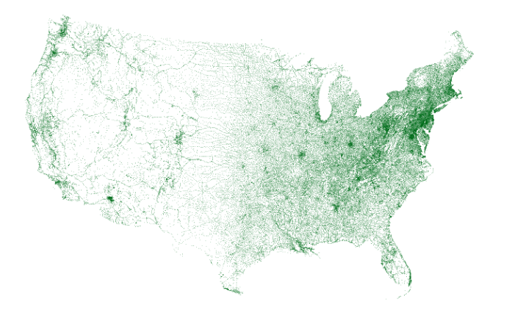

**Figure 1:** Here is a visualization of the data in our paid databases for the continental United States [1].

**Reference:**

**[1] SimpleMaps, “United States Cities Database,” SimpleMaps.com, updated June 9, 2025. [Online]. Available: https://simplemaps.com/data/us-cities**